COURSE 12: ADDITIVE MANUFACTURING FOR INDUSTRY 4.0
Team: …………………………………………………………………………………………………………………………………………………
Student’s name: …………………………………………………………………………………………………………………………………

Workshop 6 – Worksheet 6.1
Objectives of workshop:
- Analyse the influence of 3D printing parameters on mechanical characteristics of 3D printed specimens.
- Investigate the influence of 3D printing parameters on weight variations of 3D printed specimens.
- Investigate the influence of 3D printing parameters on dimensional accuracy of 3D printed specimens
Three mechanical tests should be performed on specimens: ISO 527 – tensile test specimens; ISO 178 – flexural test specimens; ISO 179 – Charpy impact test specimens. All test specimens should be printed in two directions:
Table 1: 3D printing specimen orientation for mechanical testing
TEST TYPE | ORIENTATION 1 | ORIENTATION 2
ISO 527 – tensile test specimens | 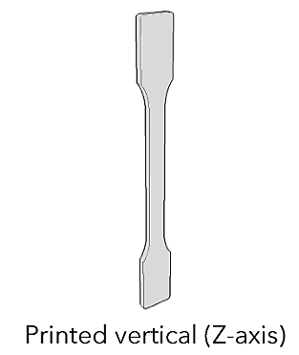  Vertical (Z axis) | 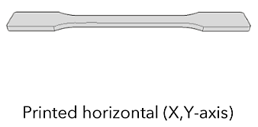  Horizontal (X, Y axes)
ISO 178 – flexural test specimens | 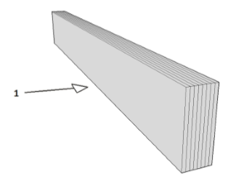  Normal | 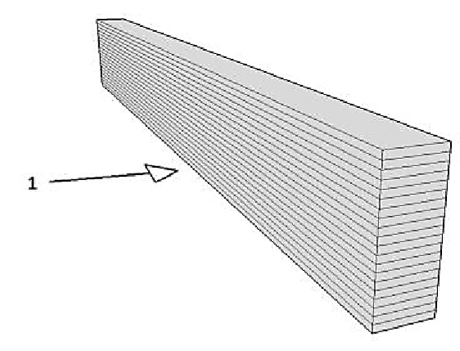  Parallel
ISO 179 – Charpy impact test specimens | 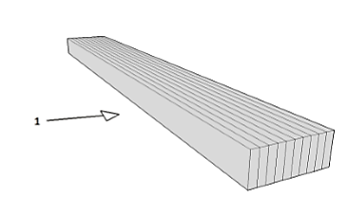  Charpy (en) | 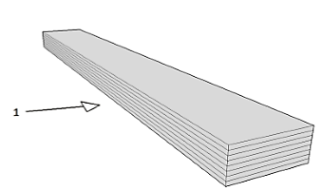  Charpy (ep)
The influence of three process parameters should be investigated:
- layer thickness (s, mm)
- printing temperature (t, degrees)
- printing speed (v, mm/min)
Use Design of Experiments (DOE) to run all tests. For each of the target responses (dependent variables) the three process parameters are considered as independent variables. On turns, you should investigate as the dependent variables the following: mass, dimension (measured in three points), mechanical tensile strength, mechanical flexural strength, mechanical impact strength. Due to the combination between the independent variables in relation to the dependent variable, a factorial experimental program is defined, with two variation levels (2³ type), with the medium values determined as the arithmetic average of the minimum and maximum limits (Table 2). Three control experiments were used, leading to a base experimental plan of 11 experiments (Table 3).
OBS: It is important that all 11 experiments within one experimental plan are conducted on the same 3D printing equipment and under the same environmental conditions.
Table 2: Variation levels for the independent natural variables
No. Crt. | Independent variable | Minimum | Medium | Maximum
1 | Layer thickness – s [mm] | 0.10 | 0.15 | 0.20
2 | Printing temperature – t [º] | 200º | 210º | 220º
3 | Printing speed – v [mm/min] | 40 mm/min | 60 mm/min | 80 mm/min

Table 3: Design of experiments for three variables – Base experimental plan
Experiment No. | Natural variables
 | s [mm] | t [º] | v [mm/min]
 | 0.15 | 210 | 60
 | 0.10 | 200 | 40
 | 0.10 | 200 | 80
 | 0.10 | 220 | 40
 | 0.10 | 220 | 80
 | 0.15 | 210 | 60
 | 0.20 | 220 | 80
 | 0.20 | 220 | 40
 | 0.20 | 200 | 80
 | 0.20 | 200 | 40
 | 0.15 | 210 | 60

While 3D printing and testing you should complete the worksheets provided in Appendix 1 of this document.

- Methodology for mass variation investigation
3D printed specimens are coded and weighted on an analytical scale (Figure 1). Values are registered in the six worksheets provided in the Appendix 1.
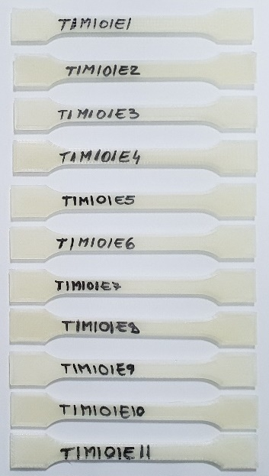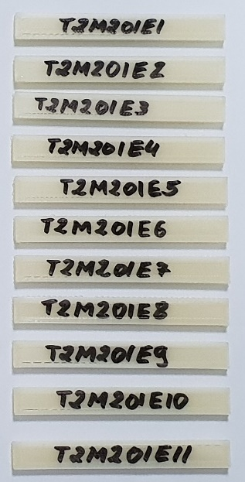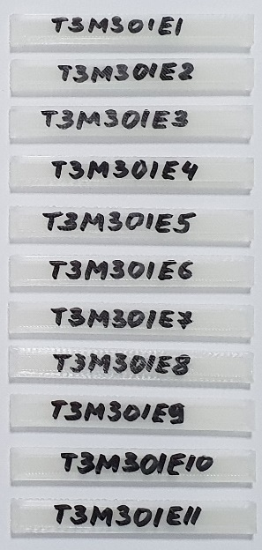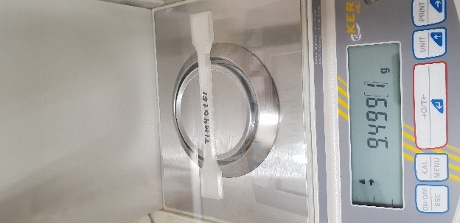
Figure 1: Example of coded specimens and weighing – a) tensile test specimens printed horizontally; b) flexural test specimens printed normal; c) Charpy impact test specimens printed normal; d) weighing of tensile test specimen printed horizontally from M4

- Methodology for dimension variation investigation
3D printed specimens are measured as provided in Figure 2 and Figure 3 below. Values are registered in the six worksheets provided in the Appendix 1.
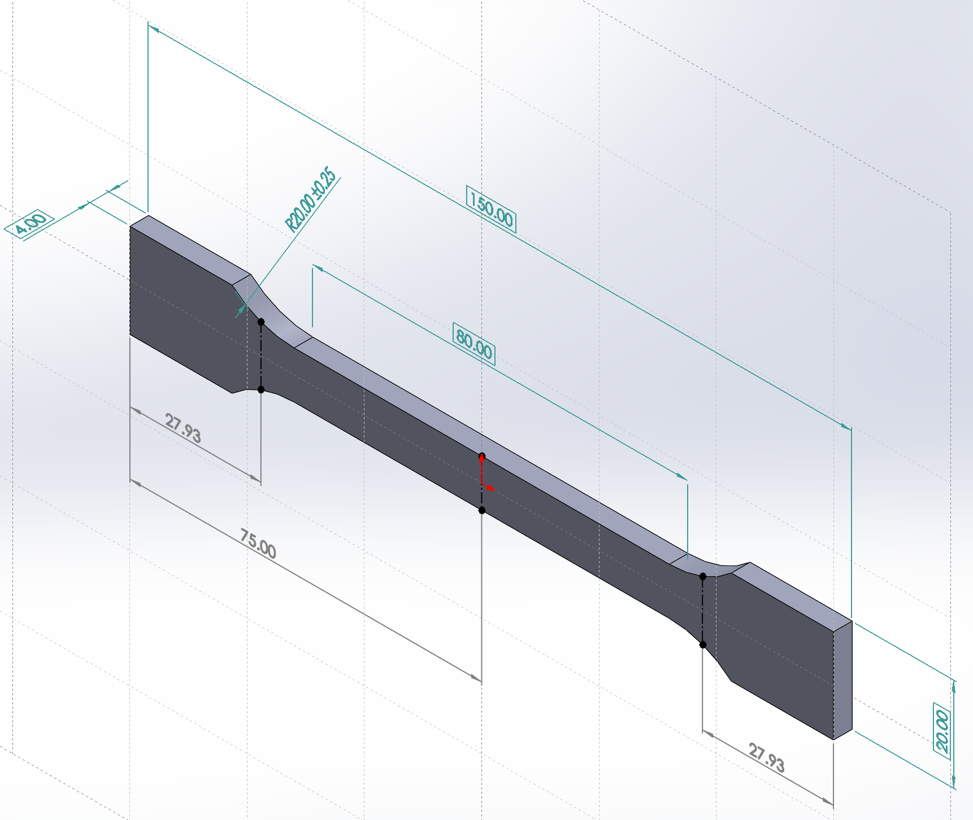
Section 1 – S1
Section 2 – S2
Section 3 – S3
Thickness – T
Figure 2. Measurement dimensions for dimensional accuracy of tensile specimens
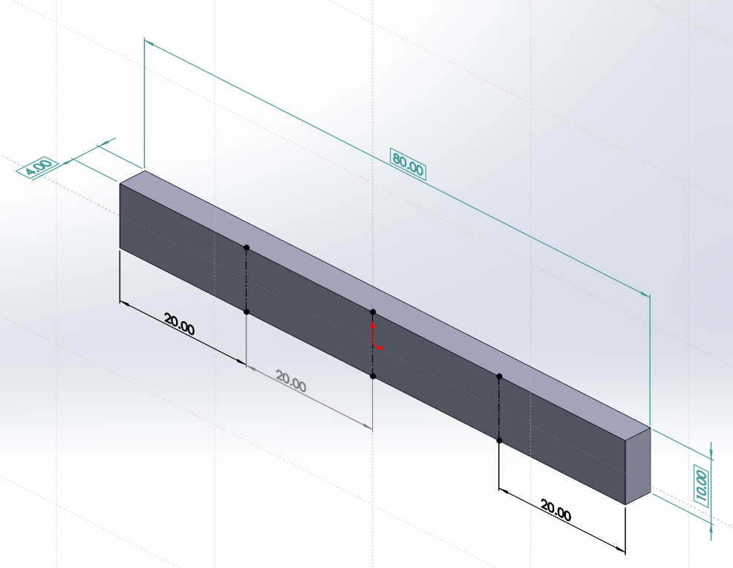
Section 1 – S1
Section 2 – S2
Section 3 – S3
Thickness – T
Figure 3. Measurement dimensions for dimensional accuracy of flexural and impact specimens

- Methodology for investigation of mechanical tensile strength
3D printed tensile specimens are mounted and tested as provided in Figure 4. Values are registered in the two worksheets provided in the Appendix 1 (Worksheet 1 & Worksheet 2).
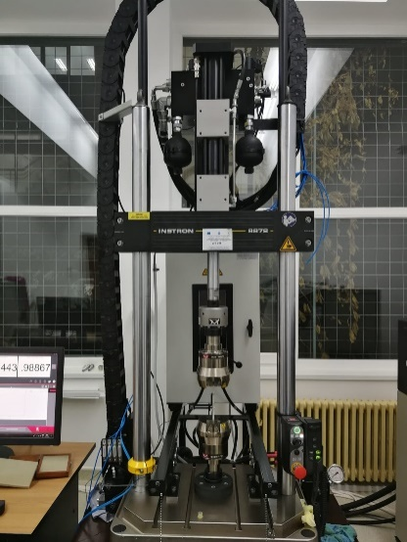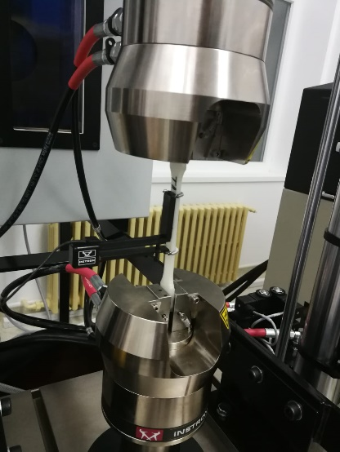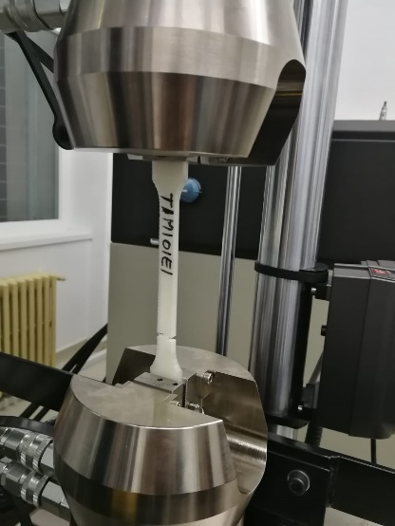
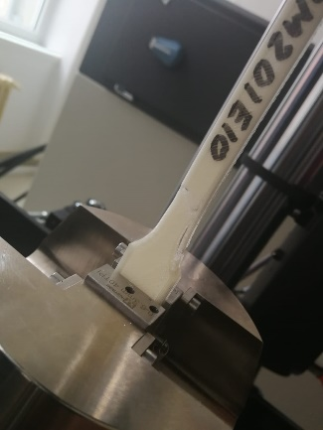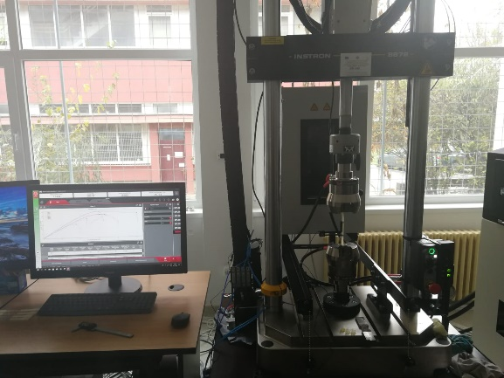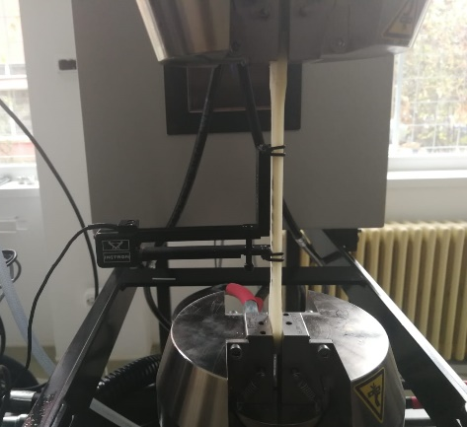
Figure 4. Experimental setup, specimen mounting and traction tests on Instron 8872-25kN
- Methodology for investigation of mechanical flexural strength
3D printed tensile specimens are mounted and tested as provided in Figure 5. Values are registered in the two worksheets provided in the Appendix 1 (Worksheet 3 & Worksheet 4).
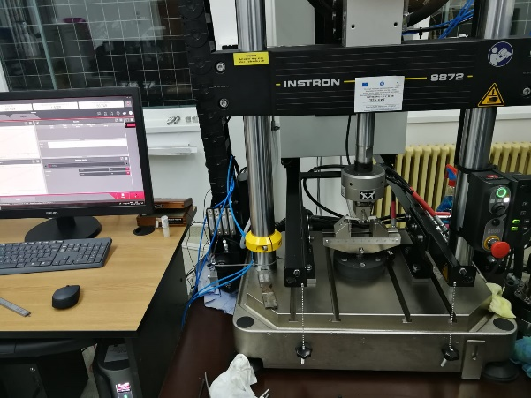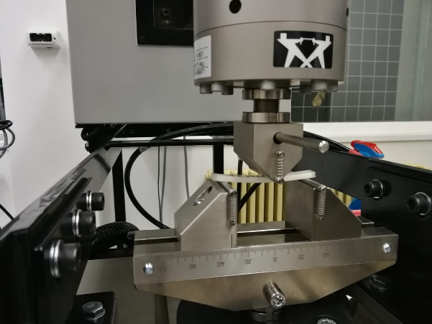
Figure 5. Experimental setup, specimen mounting and flexural tests on Instron 8872-25kN
- Methodology equipment for investigation of mechanical impact strength
3D printed impact specimens are mounted and tested as provided in Figure 6. Values are registered in the two worksheets provided in the Appendix 1 (Worksheet 5 & Worksheet 6).
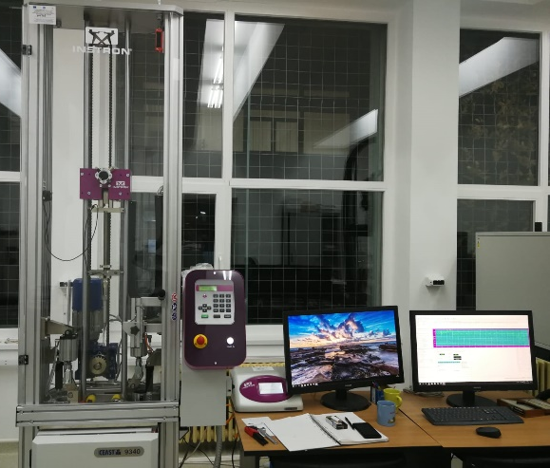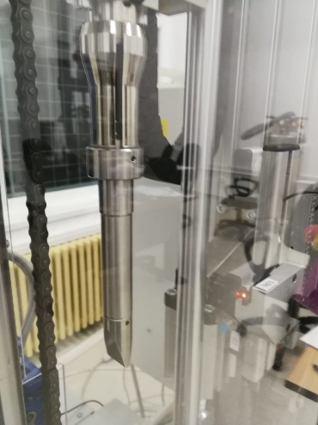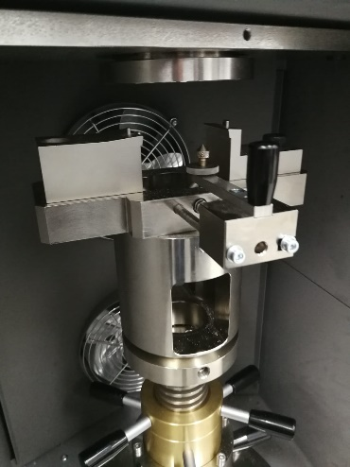
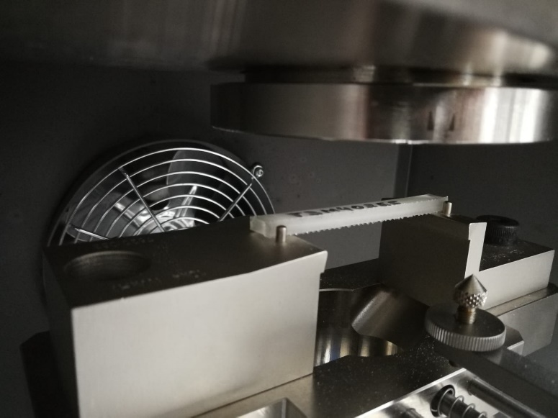
Figure 6. Experimental setup, specimen mounting and Charpy tests on Instron CEAST9340
SUPLEMENTARY TASKS:
Workshop tasks can be repeated using different filaments and you can further investigate the influence of material type into the previous research objectives.
Also, you can add extra investigation parameters and objectives, such as: supplementary measuring points, elasticity module, shear strength, elongation at break, surface roughness etc.

APPENDIX 1
WORKSHEET 1
Team no.: ……………………………………………………………………
Student name: ……………………………………………………………
Experimental program nr: 1
ISO 527 – tensile test specimens
Orientation 1 - Vertical
Filament material: ………………………………………………………

Experiment no. | Process parameters |  |  | Specimen Code¹ | Mass  [g] | Dimension² [mm] |  |  |  | MTS  [MPa]
 | s [mm] | t [º] | v [mm/min] |  |  | S1 | S2 | S3 | T
 | 0.15 | 210 | 60 | T1M1O1E1
 | 0.10 | 200 | 40 | T1M1O1E2
 | 0.10 | 200 | 80 | T1M1O1E3
 | 0.10 | 220 | 40 | T1M1O1E4
 | 0.10 | 220 | 80 | T1M1O1E5
 | 0.15 | 210 | 60 | T1M1O1E6
 | 0.20 | 220 | 80 | T1M1O1E7
 | 0.20 | 220 | 40 | T1M1O1E8
 | 0.20 | 200 | 80 | T1M1O1E9
 | 0.20 | 200 | 40 | T1M1O1E10
 | 0.15 | 210 | 60 | T1M1O1E11
¹T_{i} – Team i; M_{i} – Worksheet nr. i; O_{i} – Orientation i; E_{i} – Experiment i
² S1 – Section 1, S2 – Section 2, S3 – Section 3, T – Thickness
³ MTS – mechanical tensile strength

The following parameters are maintained constant throughout all 11 experiments: Filament diameter: 1,75 mm; Nozzle diameter: 0,4 mm; Infill: 100%; Build plate temperature: 60º; Overhang: 45º; Wall line count: 2 mm; Top/ Bottom thickness: 0,8 mm; Material flow: 100%; Ventilation: ON.

Discussion:
Compare the obtained values of the mass and dimensions with the nominal values from the CAD model.
Construct graphs for all obtained values and interpret the obtained results.

WORKSHEET 2

Team no.: ……………………………………………………………………
Student name: ……………………………………………………………
Experimental program nr: 2
ISO 527 – tensile test specimens
Orientation 2 - Horizontal
Filament material: ………………………………………………………

Experiment no. | Process parameters |  |  | Specimen Code¹ | Mass  [g] | Dimension² [mm] |  |  |  | MTS  [MPa]
 | s [mm] | t [º] | v [mm/min] |  |  | S1 | S2 | S3 | T
 | 0.15 | 210 | 60 | T1M2O2E1
 | 0.10 | 200 | 40 | T1M2O2E2
 | 0.10 | 200 | 80 | T1M2O2E3
 | 0.10 | 220 | 40 | T1M2O2E4
 | 0.10 | 220 | 80 | T1M2O2E5
 | 0.15 | 210 | 60 | T1M2O2E6
 | 0.20 | 220 | 80 | T1M2O2E7
 | 0.20 | 220 | 40 | T1M2O2E8
 | 0.20 | 200 | 80 | T1M2O2E9
 | 0.20 | 200 | 40 | T1M2O2E10
 | 0.15 | 210 | 60 | T1M2O2E11
¹T_{i} – Team i; M_{i} – Worksheet nr. i; O_{i} – Orientation i; E_{i} – Experiment i
² S1 – Section 1, S2 – Section 2, S3 – Section 3, T – Thickness
³ MTS – mechanical tensile strength

The following parameters are maintained constant throughout all 11 experiments: Filament diameter: 1,75 mm; Nozzle diameter: 0,4 mm; Infill: 100%; Build plate temperature: 60º; Overhang: 45º; Wall line count: 2 mm; Top/ Bottom thickness: 0,8 mm; Material flow: 100%; Ventilation: ON.

Discussion:
Compare the obtained values of the mass and dimensions with the nominal values from the CAD model.
Construct graphs for all obtained values and interpret the obtained results.

WORKSHEET 3

Team no.: ……………………………………………………………………
Student name: ……………………………………………………………
Experimental program nr: 3
ISO 178 – flexural test specimens
Orientation 1 - Normal
Filament material: ………………………………………………………

Experiment no. | Process parameters |  |  | Specimen Code¹ | Mass  [g] | Dimension² [mm] |  |  |  | MFS  [MPa]
 | s [mm] | t [º] | v [mm/min] |  |  | S1 | S2 | S3 | T
 | 0.15 | 210 | 60 | T1M3O1E1
 | 0.10 | 200 | 40 | T1M3O1E2
 | 0.10 | 200 | 80 | T1M3O1E3
 | 0.10 | 220 | 40 | T1M3O1E4
 | 0.10 | 220 | 80 | T1M3O1E5
 | 0.15 | 210 | 60 | T1M3O1E6
 | 0.20 | 220 | 80 | T1M3O1E7
 | 0.20 | 220 | 40 | T1M3O1E8
 | 0.20 | 200 | 80 | T1M3O1E9
 | 0.20 | 200 | 40 | T1M3O1E10
 | 0.15 | 210 | 60 | T1M3O1E11
¹T_{i} – Team i; M_{i} – Worksheet nr. i; O_{i} – Orientation i; E_{i} – Experiment i
² S1 – Section 1, S2 – Section 2, S3 – Section 3, T – Thickness
³ MFS – mechanical flexural strength

The following parameters are maintained constant throughout all 11 experiments: Filament diameter: 1,75 mm; Nozzle diameter: 0,4 mm; Infill: 100%; Build plate temperature: 60º; Overhang: 45º; Wall line count: 2 mm; Top/ Bottom thickness: 0,8 mm; Material flow: 100%; Ventilation: ON.

Discussion:
Compare the obtained values of the mass and dimensions with the nominal values from the CAD model.
Construct graphs for all obtained values and interpret the obtained results.

WORKSHEET 4

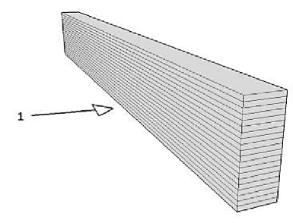
Team no.: ……………………………………………………………………
Student name: ……………………………………………………………
Experimental program nr: 4
ISO 178 – flexural test specimens
Orientation 2 - Parallel
Filament material: ………………………………………………………

Experiment no. | Process parameters |  |  | Specimen Code¹ | Mass  [g] | Dimension² [mm] |  |  |  | MFS  [MPa]
 | s [mm] | t [º] | v [mm/min] |  |  | S1 | S2 | S3 | T
 | 0.15 | 210 | 60 | T1M4O2E1
 | 0.10 | 200 | 40 | T1M4O2E2
 | 0.10 | 200 | 80 | T1M4O2E3
 | 0.10 | 220 | 40 | T1M4O2E4
 | 0.10 | 220 | 80 | T1M4O2E5
 | 0.15 | 210 | 60 | T1M4O2E6
 | 0.20 | 220 | 80 | T1M4O2E7
 | 0.20 | 220 | 40 | T1M4O2E8
 | 0.20 | 200 | 80 | T1M4O2E9
 | 0.20 | 200 | 40 | T1M4O2E10
 | 0.15 | 210 | 60 | T1M4O2E11
¹T_{i} – Team i; M_{i} – Worksheet nr. i; O_{i} – Orientation i; E_{i} – Experiment i
² S1 – Section 1, S2 – Section 2, S3 – Section 3, T – Thickness
³ MFS – mechanical flexural strength

The following parameters are maintained constant throughout all 11 experiments: Filament diameter: 1,75 mm; Nozzle diameter: 0,4 mm; Infill: 100%; Build plate temperature: 60º; Overhang: 45º; Wall line count: 2 mm; Top/ Bottom thickness: 0,8 mm; Material flow: 100%; Ventilation: ON.

Discussion:
Compare the obtained values of the mass and dimensions with the nominal values from the CAD model.
Construct graphs for all obtained values and interpret the obtained results.

WORKSHEET 5

Team no.: ……………………………………………………………………
Student name: ……………………………………………………………
Experimental program nr: 5
ISO 179 – Charpy impact test specimens
Orientation 1 – Charpy (en)
Filament material: ………………………………………………………

Experiment no. | Process parameters |  |  | Specimen Code¹ | Mass  [g] | Dimension² [mm] |  |  |  | MIS  [kJ/m²]
 | s [mm] | t [º] | v [mm/min] |  |  | S1 | S2 | S3 | T
 | 0.15 | 210 | 60 | T1M5O1E1
 | 0.10 | 200 | 40 | T1M5O1E2
 | 0.10 | 200 | 80 | T1M5O1E3
 | 0.10 | 220 | 40 | T1M5O1E4
 | 0.10 | 220 | 80 | T1M5O1E5
 | 0.15 | 210 | 60 | T1M5O1E6
 | 0.20 | 220 | 80 | T1M5O1E7
 | 0.20 | 220 | 40 | T1M5O1E8
 | 0.20 | 200 | 80 | T1M5O1E9
 | 0.20 | 200 | 40 | T1M5O1E10
 | 0.15 | 210 | 60 | T1M5O1E11
¹T_{i} – Team i; M_{i} – Worksheet nr. i; O_{i} – Orientation i; E_{i} – Experiment i
² S1 – Section 1, S2 – Section 2, S3 – Section 3, T – Thickness
³ MIS – mechanical impact strength

The following parameters are maintained constant throughout all 11 experiments: Filament diameter: 1,75 mm; Nozzle diameter: 0,4 mm; Infill: 100%; Build plate temperature: 60º; Overhang: 45º; Wall line count: 2 mm; Top/ Bottom thickness: 0,8 mm; Material flow: 100%; Ventilation: ON.

Discussion:
Compare the obtained values of the mass and dimensions with the nominal values from the CAD model.
Construct graphs for all obtained values and interpret the obtained results.

WORKSHEET 6

Team no.: ……………………………………………………………………
Student name: ……………………………………………………………
Experimental program nr: 6
ISO 179 – Charpy impact test specimens
Orientation 2 – Charpy (ep)
Filament material: ………………………………………………………

Experiment no. | Process parameters |  |  | Specimen Code¹ | Mass  [g] | Dimension² [mm] |  |  |  | MIS  [kJ/m²]
 | s [mm] | t [º] | v [mm/min] |  |  | S1 | S2 | S3 | T
 | 0.15 | 210 | 60 | T1M6O2E1
 | 0.10 | 200 | 40 | T1M6O2E2
 | 0.10 | 200 | 80 | T1M6O2E3
 | 0.10 | 220 | 40 | T1M6O2E4
 | 0.10 | 220 | 80 | T1M6O2E5
 | 0.15 | 210 | 60 | T1M6O2E6
 | 0.20 | 220 | 80 | T1M6O2E7
 | 0.20 | 220 | 40 | T1M6O2E8
 | 0.20 | 200 | 80 | T1M6O2E9
 | 0.20 | 200 | 40 | T1M6O2E10
 | 0.15 | 210 | 60 | T1M6O2E11
¹T_{i} – Team i; M_{i} – Worksheet nr. i; O_{i} – Orientation i; E_{i} – Experiment i
² S1 – Section 1, S2 – Section 2, S3 – Section 3, T – Thickness
³ MIS – mechanical impact strength

The following parameters are maintained constant throughout all 11 experiments: Filament diameter: 1,75 mm; Nozzle diameter: 0,4 mm; Infill: 100%; Build plate temperature: 60º; Overhang: 45º; Wall line count: 2 mm; Top/ Bottom thickness: 0,8 mm; Material flow: 100%; Ventilation: ON.

Discussion:
Compare the obtained values of the mass and dimensions with the nominal values from the CAD model.
Construct graphs for all obtained values and interpret the obtained results.

