COURSE 12: ADDITIVE MANUFACTURING FOR INDUSTRY 4.0

Student’s name: …………………………………………………………………………………………………………………………………

Workshop 5 – Worksheet 5.1

Choose a partner and solve the tasks given below. Discuss with your teacher whenever necessary.
Task 01:
Solve the multiple-choice quiz on Additive Manufacturing Technologies. Please justify your answer on a different sheet of paper (if needed).
1. Rapid prototyping and additive manufacturing are two terms that refer to fabrication technologies that add layers of material to an existing part or substrate: (a) true or (b) false?
2. A computer model of a part design on a CAD system is called which of the following (one best answer): (a) computer prototype, (b) geometric prototype, (c) solid prototype, (d) virtual prototype, or (e) wire-frame prototype?
3. Machining is never used for rapid prototyping because it takes too long: (a) true or (b) false?
4. Which one of the following rapid prototyping processes uses a photosensitive liquid polymer as the starting material: (a) droplet deposition manufacturing, (b) fused-deposition modelling, (c) laminated-object manufacturing, (d) selective laser sintering, (e) stereolithography, or (f) three-dimensional printing?
5. Which of the following AM technologies uses powders as the starting material: (a) droplet deposition manufacturing, (b) fused-deposition modelling, (c) laminated-object manufacturing, (d) selective laser sintering, (e) stereolithography, or (f) three-dimensional printing?
6. Which of the following AM technologies uses molten material as the starting material: (a) droplet deposition manufacturing, (b) fused-deposition modelling, (c) laminated-object manufacturing, (d) selective laser sintering, (e) stereolithography, or (f) three-dimensional printing?
7. Which one of the following AM technologies uses solid sheet stock as the starting material: (a) droplet deposition manufacturing, (b) fused-deposition modelling, (c) laminated-object manufacturing, (d) selective laser sintering, (e) stereolithography, or (f) three-dimensional printing?
8. Which of the following are examples of appropriate applications of additive manufacturing in the actual production of parts and products: (a) castings made in small quantities, (b) customized one-of-a-kind parts, (c) mass-produced metal parts, (d) parts with intricate and/or complex geometries, (e) plastic parts in small batch sizes, and (f) special textile products?
9. A critical measure of suitability of certain polymers to replace metals in structural applications is: (a) Surface Finish, (b) Material cost, (c) Material availability, (d) Strength-to-density ratio.
10. During the post processing of stereolithography parts, the following solvents are used, EXCEPT: (a) Polyflush, (b) TPM (tripropylene glycol monomethyl ether), (c) Acetone, (d) Alcohol.

Task 02:
Please indicate the similarities and differences between the following Additive Manufacturing technologies:
(a) Stereolithography and Material Jetting
(b) Binder Jetting and Laminated Object Manufacturing.
……………………………………………………………………………………………………………………………………………………………………….

Task 03:
Please indicate the similarities and differences between the following Additive Manufacturing technologies:
- Selective Laser Sintering and Selective Laser Melting
- Material Jetting and Fused Deposition Modelling
……………………………………………………………………………………………………………………………………………………………………….

Task 04:
The engine case/ hydraulic block manifold presented in the figure below was redesigned for additive manufacturing. Please complete the table below and use it to select the most appropriate manufacturing technology for the engine case. Make sure to justify your option by a short commentary given on a separate sheet of paper. Was it a good decision to redesign for AM? (Please comment)
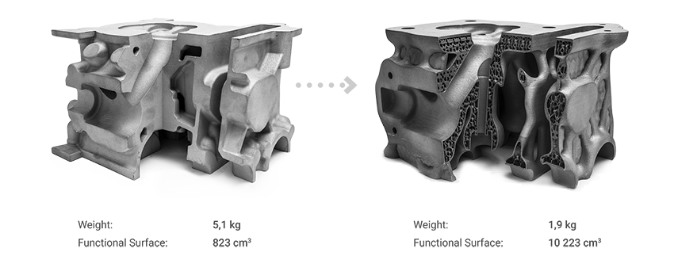

 | CNC | Binder Jetting | SLM/ DMLS
Cost
Common materials
Lead time
Accuracy
Mechanical properties
Advantages
Disadvantages

……………………………………………………………………………………………………………………………………………………………………….
……………………………………………………………………………………………………………………………………………………………………….
……………………………………………………………………………………………………………………………………………………………………….
Task 05:
The engine case/ hydraulic block manifold presented in the figure below was redesigned for additive manufacturing. Please complete the table below and use it to select the most appropriate manufacturing technology for the engine case. Make sure to justify your option by a short commentary given on a separate sheet of paper. Was it a good decision to redesign for AM? (Please comment)

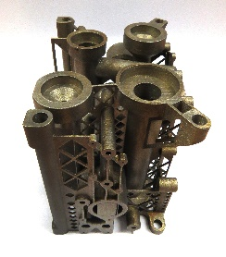

 | CNC | Binder Jetting | SLM/ DMLS
Cost
Common materials
Lead time
Accuracy
Mechanical properties
Advantages
Disadvantages

……………………………………………………………………………………………………………………………………………………………………….
……………………………………………………………………………………………………………………………………………………………………….
……………………………………………………………………………………………………………………………………………………………………….

Task 06:
What are the limitations of additive manufacturing? Please write a short essay on the limitations of the different AM technologies, specifying when should AM be chosen as the main manufacturing technology in a production process. What are the key criteria for selecting the right 3D printing process for production of a given part?

……………………………………………………………………………………………………………………………………………………………………….

