COURSE 12: ADDITIVE MANUFACTURING FOR INDUSTRY 4.0

Student’s name: …………………………………………………………………………………………………………………………………

Workshop 4 - Worksheet 4.1

Consider the product given in the pictures below and the given appendix (see document MSIE-12-T-M2S3-W02).

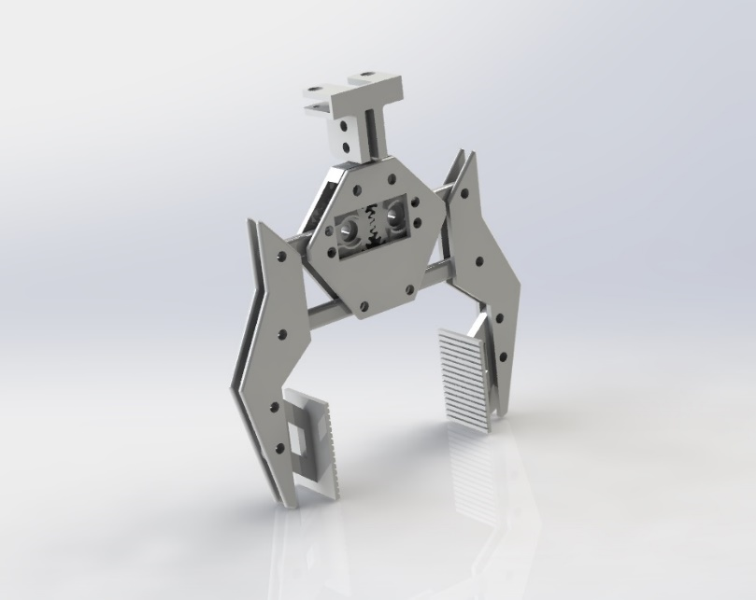

Choose a partner and answer the below questions. Discuss with your teacher whenever necessary. To answer some of the questions you will require to design the CAD parts, STL and Gcodes for the given product.

- Specify the equipment used in the ZSuite/ Cura Ultimaker software application to generate the .gcode and .3mf / .zprojx files of the given product.

- Specify the material used in the ZSuite/ Cura Ultimaker software application to optimize the 3D printing parameters of the given product.

- Specify the diameter of the 3D printing nozzle and the diameter of the filament used to optimize the manufacturing parameters.

- Specify the orientation surface on the build plate of the 3D printing equipment of the product components. Justify the choice.

- Specify which 3D printing profile you use to optimize the manufacturing parameters in ZSuite/ Cura for the given product. Justify the choice.

- Mention the optimal wall thickness of the part (Shell) that you selected when optimizing the 3D printing parameters of the given part. Justify the choice.

- Depending on the equipment and material used, specify the print head and 3D printer table temperature used for 3D printing of the given item.

- Specify the 3D printing speed set for additive manufacturing of the given product. Justify the choice.

- Specify whether support structures are required for 3D printing of the given part and specify their characteristics and role.

- Specify the type of support structures and their characteristics for optimal 3D printing of the given part.

- Select the parameter for each type of adhesive structure to the 3D printer build plate.

- Specify the Infill density used to 3D print the designed parts. Justify the choice.

- Specify the 3D print time for the given parts after generating the G codes. Mention two ways to reduce the print time, in accordance to the characteristics of the designed components.

- Specify the total mass of the given products/ individual components after optimizing the parameters and generating the G codes. Mention two ways to reduce the mass of the parts, in correlation to the characteristics of the assembly.

- Specify the total length of the consumed filament after optimizing the parameters and generating the G codes for your assembly. Mention two ways to reduce the length of the fillament used, in correlation to the characteristics of the given part.

- Specify how much time (in minutes) it takes to generate the Outer wall of the parts after the generation of the G codes.

- Specify what percentage of the total 3D printing time is the duration of the interior filling structures (Infill). Mention two ways to reduce this duration, in accordance with the characteristics of the part and the selected type of infill structure.

- Specify what other technology can be used for 3D printing of the designed assembly, while maintaining its functional role. Specify the optimal material for the new selected technology. Justify the choices.

