COURSE 12: ADDITIVE MANUFACTURING FOR INDUSTRY 4.0

Student’s name: …………………………………………………………………………………………………………………………………

Workshop 2 – Worksheet 2.1

This workshop is performed individually.
- Task 01:

- Please write down the main Additive Manufacturing technologies that you remember from class lecture. Make sure that you group them by the main seven working principles. After discussion with your teacher complete what missing information you might have.

- Task 02:

- Complete the table below with the main requirements of the design rules in 3D printing. After discussion with your teacher add any missing information.

 | Supported walls | Unsupported  Walls | Support &  Overhangs | Embossed &  Engraved  Details | Horizontal  Bridges | Holes | Connecting  /Moving  Parts | Escape  Holes | Minimum  Features | Pin  Diameter | Tolerance
Fused
Deposition
Modeling

Stereolithography

Selective
Laser
Sintering

Material
Jetting

Binder
Jetting

Direct
Metal Laser
Sintering

- Task 03:
After discussing with your teacher and your team colleagues, write down the mail available infrastructure, identifying for each equipment the appropriate AM technology. List the available materials for 3D printing and the necessary resources for the laboratory outline. After completion of task, discuss with your colleagues and present the teacher with final complete answers.

……………………………………………………………………………………………………………………………………………..

- Task 04:
- Fill in the missing equipment components from the sketch below. Discussion with teammates and teacher are advised.
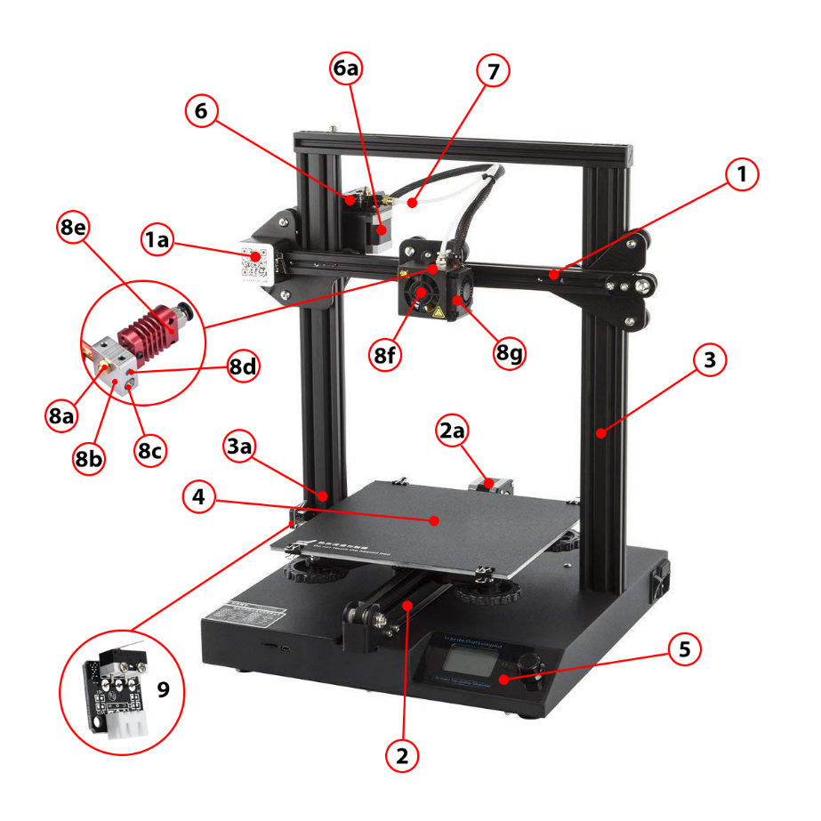
……………………………………………………………………………………………………………………………………………..

- Write down the FDM working principle after discussions with your teammates and teacher.
……………………………………………………………………………………………………………………………………………..

- Task 05:
- Perform together with your teacher the following maintenance routines on an FDM 3D printer and write down the main process stages for each one.

- Bead heating and cooling…………………………………………………………………………………………………….

- Bed levelling………………………………………………………………………………………………………………………..

- Filament change……………………………………………………………………………………………………………………

- Axis movement verification……………………………………………………………………………………………………

- Material purge and component check……………………………………………………………………………………

- Part removal from printing platform……………………………………………………………………………

