Lab Sheet: Chair Assembly
Introduction
Assembling a chair in a factory. Entrepreneurs use human labor to assemble the chair, which is very time consuming, so to meet with the industrial age 4.0. The operator agreed that robots should be used in assembly work. The operator would like to know how if using robots to assemble instead of people, how will they affect each station?
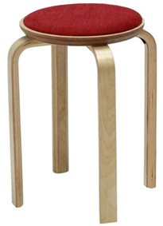1 set = (5*Wood)+(8 Bolt)
Figure 1. Chair
The processes are showed in Figure 2.
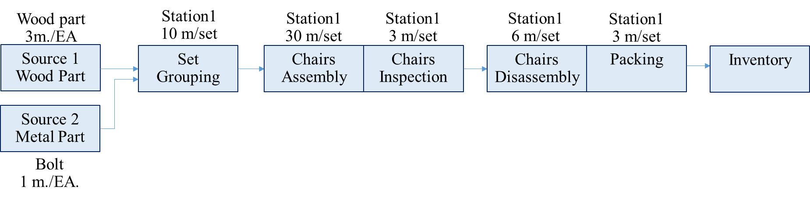
Figure 2. Production process of Chair assembly
Assignment
- Created simulation model of the chair assembly by used Tecnomatix.
- Question 1: From the process of assembling a chair, how many chairs will be stored in inventory in 8 hours? And How about utilization in each stations?
- Question 2: If the automatic robotic system is used in the chair assembly process, which has the capability of assembling 5 m./set. How production change?
Objective
This lab reinforces the following skill:
- Concept of Digital Twin and Simulation.
- Manipulate parameters of the model to achieve the goal.

Instruction
- Set raw materials consisting of wood, metal, pallet.
- Use robots to pick materials from source to conveyor.
- Convey parts using a conveyor.
Name__________________________________________ ID________________________________

Created simulation model of the chair assembly by used Tecnomatix.

2D

3D

Question 1: From the process of assembling a chair, how many chairs will be stored in inventory in 8 hours? How about utilization in each stations?
(Explain from Resource Statistics, Throughput)

Discuss result from stimulation

Question 2: If the automatic robotic system is used in the chair assembly process, which has the capability of assembling 5 m./set. How production change?
(Explain from Resource Statistics, Throughput)

Discuss result from stimulation

Summary

