Lab Sheet: Gear factory
Introduction
Industrial 4.0 is the trend towards automation and data exchange in manufacturing technology and processes with include cyber-physical systems and another state of the art technology such as internet of things, cloud computing, artificial intelligent etc. The one component of cyber-physical systems is digital twin.
A digital twin is a digital replica of physical entity. By connecting the physical and the virtual world, data is transmitted seamlessly allowing the virtual entity to exist simultaneously with the physical entity. In various industrial sectors, digital twin is being used to optimize the operation and maintenance of physical assets, systems and manufacturing processes.
This lab has process follows,
- Blank parts (raw material) arrive by pallet at Receive location. The Work piece arrives at pallet 5 minutes per 1 piece.
- From the Receive location they are sent to NC Lathe1 or NC Lather2, where they undergo a lathe operation to be Cog that takes an average of 3 minutes.
- The cogs go to the degrease location, where they are batched of two pieces then removed exceed grease by degreasing machine that take 5 minutes.
- After degreasing, each cog goes to the inspection location. For the inspection process take a time that is uniformly distributed with a minimum 4minutes.
- The last process is assembly the passing cogs with a bearing that takes a minimum 2 minutes uniformly distributed.

The processes are showed in Figure 1. There is only one operator in the department to operate all processes. You need to improve this process with the goal to reduce cost per unit and increase production rate. You are interesting in the number of operator. Unfortunately, you cannot experiment with the physical system. In this situation, you may think about the digital twin.
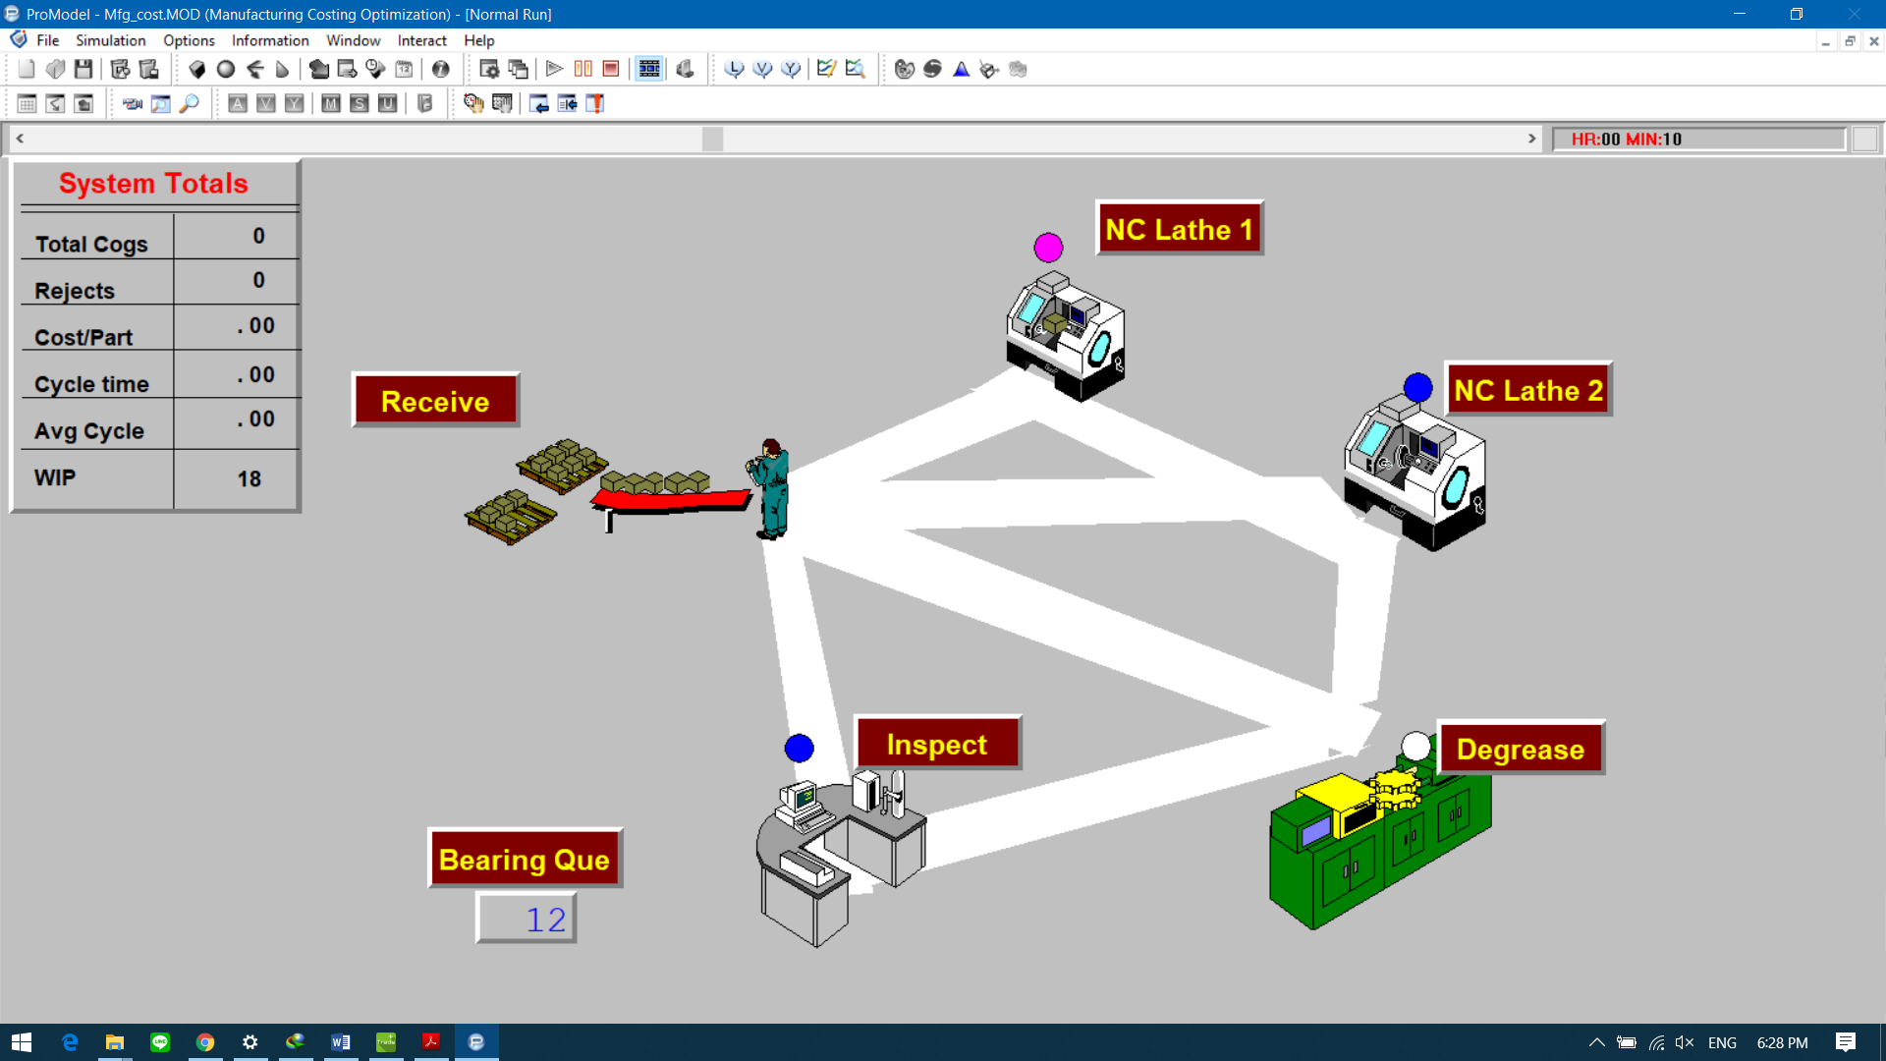
Figure 1 Layout of gear factory

Assignment
Created simulation model of the gear factory by used Tecnomatix. Simulate the system for 10 hours of scenario then track production rate. If the goal of improvement is increase production rate and productivity line balancing, how to do you improve the production line?
Objective
This lab reinforces the following skill:
- Concept of Digital Twin and Simulation.
- Manipulate parameters of the model to achieve the goal.
Instruction
- Layout the factory as appropriate and have the specified process.
- Use robots to pick materials from source to conveyor.
- Convey parts using a conveyor.

Name__________________________________________ ID________________________________

Created simulation model of the gear factory by used Tecnomatix.

2D

3D
Scenario
Production rate

Resource Statistics

Discuss result from stimulation

If the goal of improvement is increase production rate and productivity line balancing, how to do you improve the production line?
Created simulation model of the gear factory by used Tecnomatix.
Extended model of Degrease

2D

3D

Scenario
Production rate
Resource Statistics

Discuss result from stimulation (after improvement)

Summary

