Lab Sheet: Cyber Physical System (CPS) and Data Security
Introduction
A cyber physical system (CPS) is a complex system that integrates computation, communication, and physical processes. Digital manufacturing is a method of using computers and related technologies to control an entire production process. Industry 4.0 can make manufacturing more efficient, flexible, and sustainable through communication and intelligence; therefore, it can increase the competitiveness. Key technologies such as the Internet of Things, cloud computing, machine-to-machine (M2M) communications, 3D printing, and Big Data have great impacts on Industry 4.0. Therefore, CPS is the way to streamlining process in a production line of an existing traditional factory using a data flow diagram for Digital factory is important.
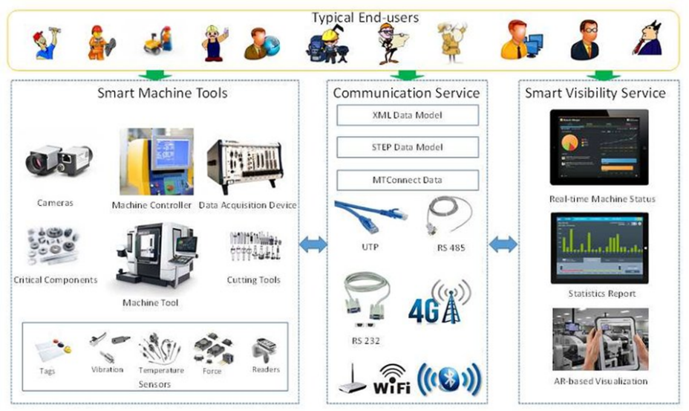
- Application of CPS in manufacturing process.

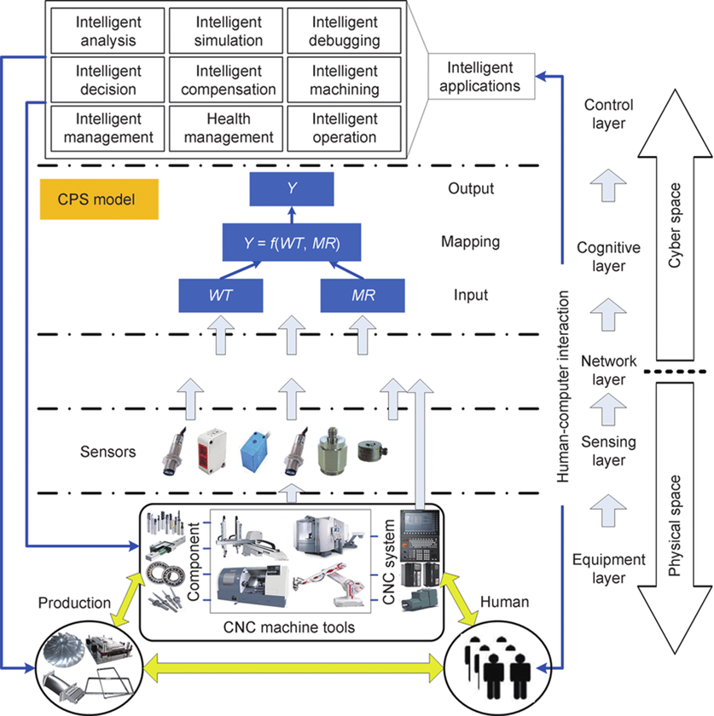

The CPS architecture of CNC machine tools with a CPS model

Assignment
Design and development of a system for CNC turning to be in the form of Cyber-Physical Production Systems by writing architecture, data flow diagram and some available services. Streamlining process in the production line of CNC turning. Use data below:
- CNC turning FANUC Series 18i MODEL B
- A series of Ultra-Compact, Ultra-Thin CNC with Embedded network interface
- integrated with LCD display and network features
- High Speed, High Precision and High Efficiency (High Precision Nano CNC System, State of the Art Servo Technology (HRV control), High Performance PMC to Reduce Cycle Time)
- Versatile Network Function (Ethernet Interface as Standard, Integrated Supervising Software Package by Networking)
- FOCAS 1 Driver
- Sockets (164.41.17.20:8193)
Objective
This lab reinforces the following skill:
- Concept of CPS in manufacturing process
- Design architecture, data flow diagram of CPS to streamlining process in a production line of an existing traditional factory.
Instruction
- Read and understand the content and application of CPS in manufacturing process.
- Design and development of a system for CNC turning to be in the form of Cyber-Physical Production Systems by writing architecture, data flow diagram and some available services.
- You can search the equipment of physical and cyber space for design on the internet.

Name__________________________________________ ID________________________________
Cyber-Physical Production Systems: architecture, data flow and some available services

