Activity/Event Report Form

Activity/Event Name | MSIE 4.0 Public Seminar
Work Package | WP5 |  | Task no. | 5.6
Date of activity/event: | Mar 6, 2019 |  | Time: | 9:00-12:00
Host | CMU |  | Location: | JW Marriott Hotel Bangkok
1. Attendance or Participants
Name |  | Organization
- IEOM participants
20 persons
2.
3.
4.
5.
6.
7.
8.
9.
10.
11.
12.
13.
14.
15.
16.
17.
18.
19.
20.
2. Purpose of Event/activity
2.1 To introduce the MSIE 4.0 in the “Industry 4.0” track in the 9th International Conference on Industrial Engineering and Operations Management (9th IEOM) held in Bangkok, Thailand.
2.2 To share knowledge on how Industry 4.0 could impact the business and how the company and academic should prepare for it.

3. Agenda
Date: March 6, 2019 (16;30-18:00)
Venue: JW Marriott Hotel Bangkok
Agenda:
- How industry 4.0 impact the business and how they prepare for the future?
- How to enhance the students’ competency for the I4.0?
4. Outcomes
4.1 The audiences have realized the role of Industrial engineers on the Industry 4.0.
4.2 The role of academic to prepare for the I4.0 by developing the curriculum for industrial engineering to support Thailand sustainable smart industry.

5. Attachments (documents/handouts, printed material, photos, etc.)
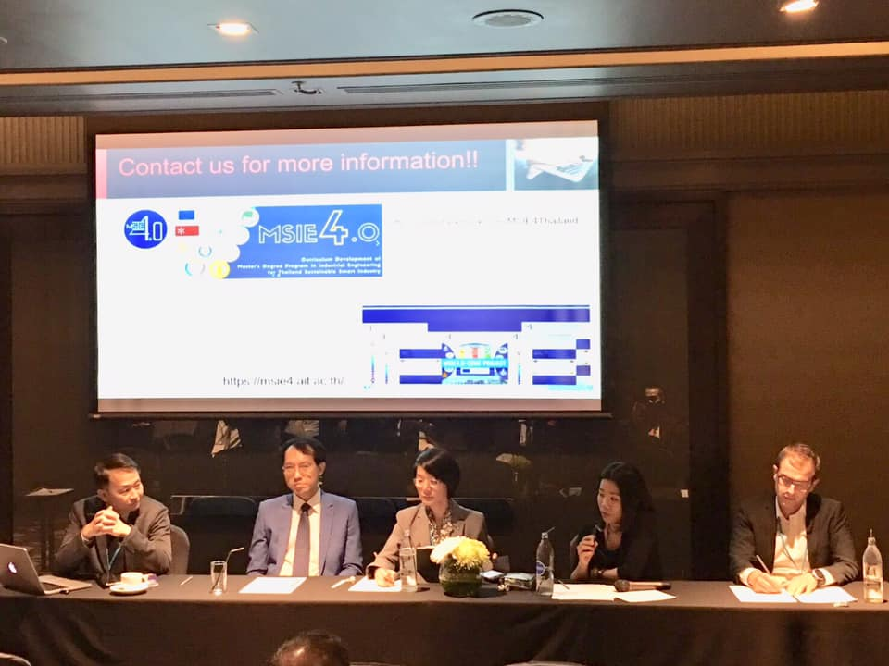

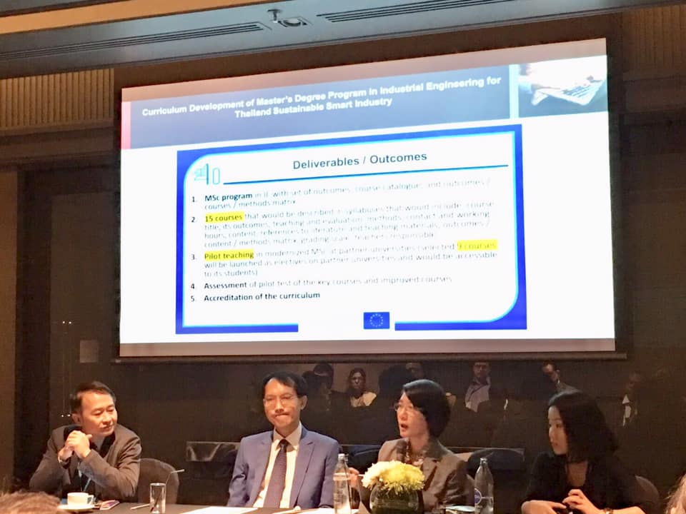

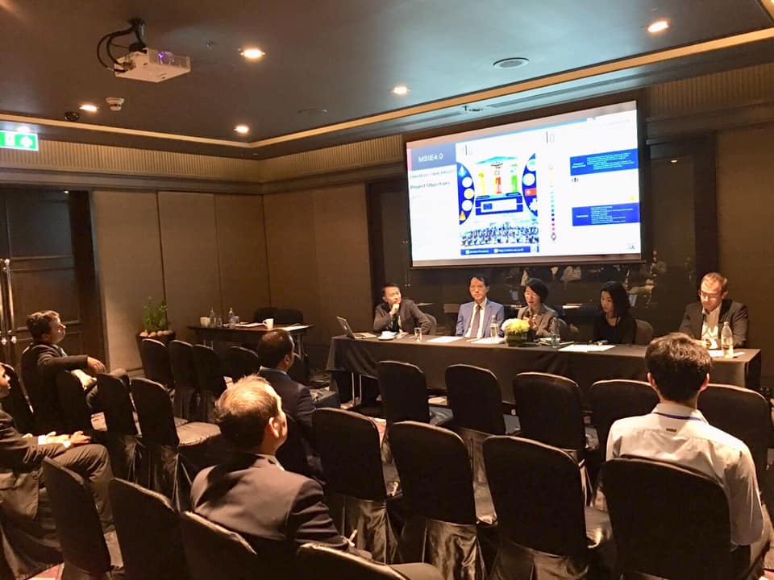

6. Others

