Activity/Event Report Form

Activity/Event Name | Presentation of MSIE 4.0 Project research to Her Royal Highness Princess Maha Chakri Sirindhorn at KMUTNB
Work Package | 5 |  | Task no. | 5.4
Date of activity/event: | 15 March 2019 |  | Time: | 9:00-12:00
Host | KMUTNB |  | Location: | KMUTNB
1. Attendance or Participants
Name |  | Organization
- Assoc. Prof. Dr. Pisut Koomsap |  | Asian Institute of Technology
2. Prof. Dr. Athakorn Kengpol |  | King Mongkut’s University of Technology North Bangkok
3.
4.
2. Purpose of Event/activity
- Presentation of MSIE 4.0 Project research to Her Royal Highness at KMUTNB.
- Presentation of MSIE 4.0 Project research to lecturer, student, Industry and other people.

3. Agenda
Presentation to Her Royal Highness
Billboard Presentation
Video Clip Presentation
Newspaper
4. Outcomes
Her Royal Highness Princess Maha Chakri Sirindhorn presided over the opening ceremony of the Exhibition of Science and Modern Technology to celebrate the 60th year of KMUTNB. For this occasion, Prof. Athakorn Kengpol and Assoc. Prof. Dr. Pisut Koomsap had the honor to present to Her Royal Highness our MSIE 4.0 project on behalf of our community.

Research Project information had been presented in formats such as billboard, television news, KMUTNB Facebook, video clip, newspaper.

5. Attachments (documents/handouts, printed material, photos, etc.)
https://www.facebook.com/MSIE4Thailand/photos/a.344582899359883/575680816250089/?type=3&eid=ARDhBQCpUPSgBfMSB212II9-9RO-CKm1Y3ktyHDlHs6ZgSQhUHHtDkpntksvEp-XQmebnO25C2qrjz_E&__xts__%5B0%5D=68.ARDVjRwDdYZIQOX-m7n78KZAsjjAh1oRSCRYU6qcG6r47Ybi2WW8UbCcDPqWrsUMoKNMmVPQTj8Lo8e6ltOrHQgMY6xNfgRlOexshhNY5zrH13CEs-z1NDfFXIkXRo9vMdhAhva508FpvrDpjhbQOooSB0rMafXeMcAB-BZ__XcXakGqJDYxzSgmxx_huy38qedYsl9wNNzGUdFfS5IwN9aQG-4ShFR0Vxy59BILQFGXxxcorgtbqHpDcT3p-sIRSyIyJDZ9BRRSwseIRhiO8-7cg_Wa7c5fyqSPbY01vvuaXB95_F4l9i6-yjWEPUgUqw-l9hvNZ864QN0V9ZBUp-A&__tn__=EHH-R
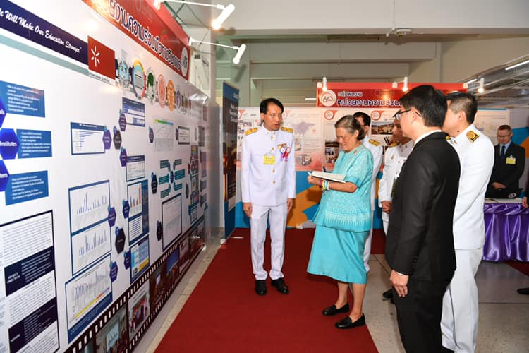

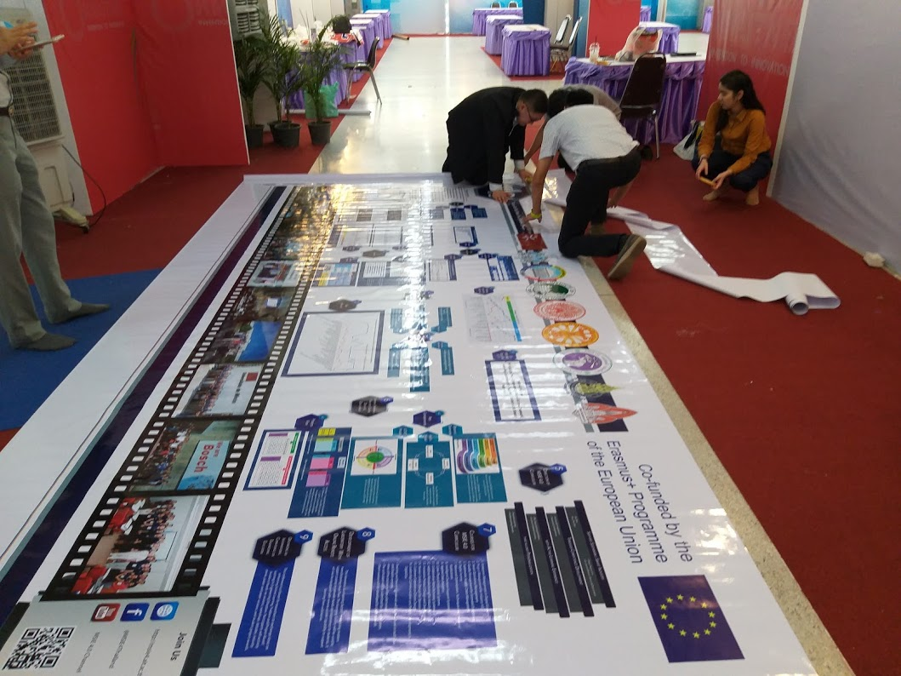
6. Others

